Biology Unit Test Ch 11,12,14 Study Guide
Ch 11

- What did Gregor Mendel use pea plants to study?
- Why did Gregor Mendel removed the male parts from the flowers of some plants?
- What are the chemical factors that determine traits are called?
- What did F₁ plants inherit when Gregor Mendel crossed a tall plant with a short plant?
- What does the principle of dominance state?
- When Gregor Mendel crossed true-breeding tall plants with true-breeding short plants, all the offspring were tall. Why?
- If a pea plant has a recessive allele for green peas, when will it produce yellow peas? green peas?
- A tall plant is crossed with a short plant. If the tall F₁ pea plants are allowed to self-pollinate,what will the offspring look like?
- In the P generation, a tall plant was crossed with a short plant. Short plants reappeared in the F₂ generation. Why?
- What can the principles of probability can be used for?
- In the P generation, a tall plant is crossed with a short plant. What is the probability that an F₂ plant will be tall?
- Organisms that have two identical alleles for a particular trait are said to be________?

 |  |  | Tt
 |  | T |  | t
TT | T | TT |  | Tt
 | T | TT |  | Tt

T | = | tall
t | = | short

Figure 11-1

13.In the Punnett square shown in Figure 11-1, what are the percentages of the phenotypes produced?
14.What does a Punnett square show?
15.What principle states that during gamete formation genes for different traits separate without influencing each other’s inheritance?

16.What does the Punnett square of an F1 cross shows about the gene for pea shape and the gene for pea color?
17.How many different allele combinations would be found in the gametes produced by a pea plant whose genotype was RrYY?
18.If a pea plant that is heterozygous for round, yellow peas (RrYy) is crossed with a pea plant that is homozygous for round peas but heterozygous for yellow peas (RRYy), how many different phenotypes are their offspring expected to show?
19.Situations in which one allele for a gene is not completely dominant over another allele for that gene are called what?
20.Variation in human skin color is a result of what?
22.Gregor Mendel’s principles of genetics apply to what types of organisms?
23.If an organism’s diploid number is 12, its haploid number is what?
24.Gametes have how many alleles for each gene?
25.Gametes are produced by what process?

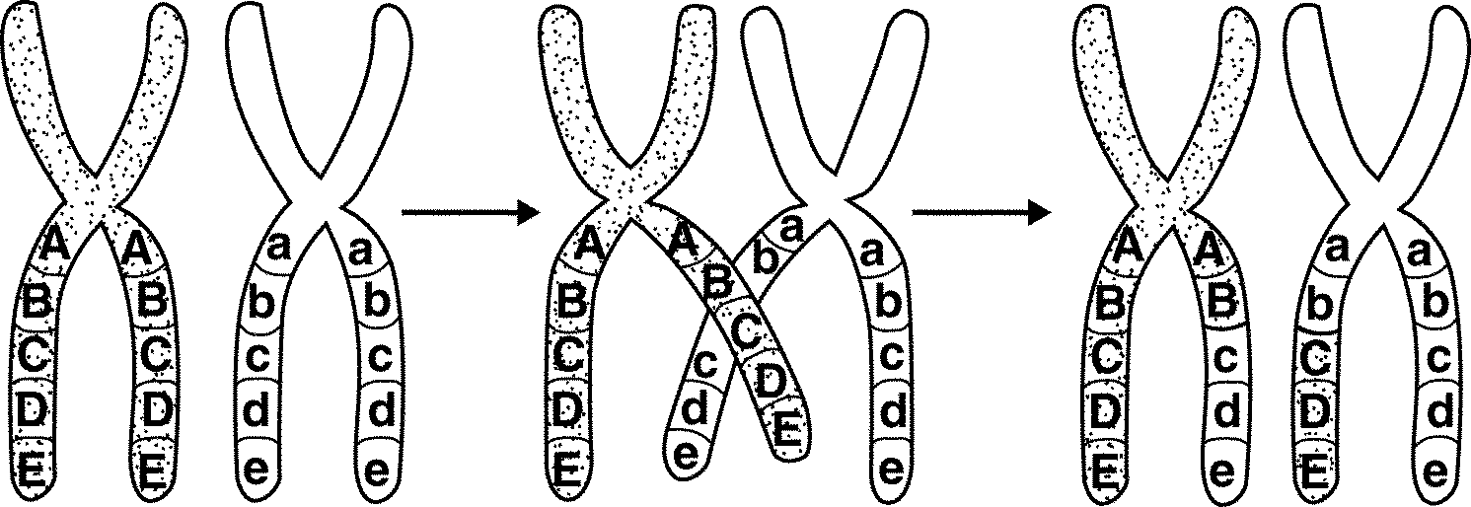

Figure 11-3

26.What is shown in Figure 11-3?
27.Unlike mitosis, meiosis results in the formation of what? (2 things)
- What are linked genes? How do they assort?
29.Gene maps are based on what?
30.If two genes are on the same chromosome and rarely assort independently, what is true about how close they are to each other?

Chapter 12

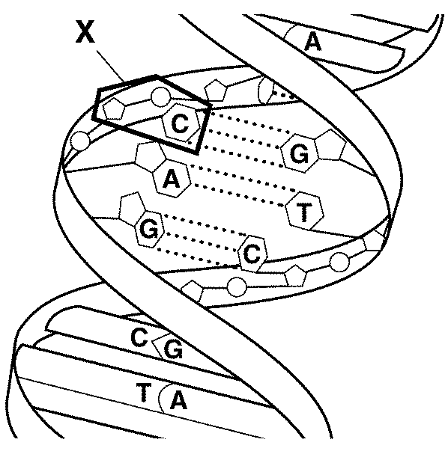

Figure 12-1

- Figure 12-1 shows the structure of what molecule?
- What are the components of a nucleotide found in DNA? RNA? What are the bases in DNA? RNA?
- Because of base pairing in DNA, what is the percentage of adenine molecules to thymine? Cytosine to guanine?
- What is the process of DNA being copied called?
- DNA replication results in two DNA molecules, each with two strands. How are the original stands and the copies arranged in the daughter molecules?
- During DNA replication, if a DNA strand that has the bases CTAGGT, it produces a strand with the base sequence _____________?

- In eukaryotes, where is the DNA located?
- During mitosis, the what happens to the DNA in the nucleosomes?
- Order the following from least to most complex: DNA molecules, histones, chromosomes, nucleosomes
10.How many main types of RNA are there?
11.Which type(s) of RNA is(are) involved in protein synthesis?
12.Which RNA is copied from DNA?
13.What is produced during transcription?
14.During transcription, an RNA molecule is formed. Is it identical or complementary to the DNA strand?
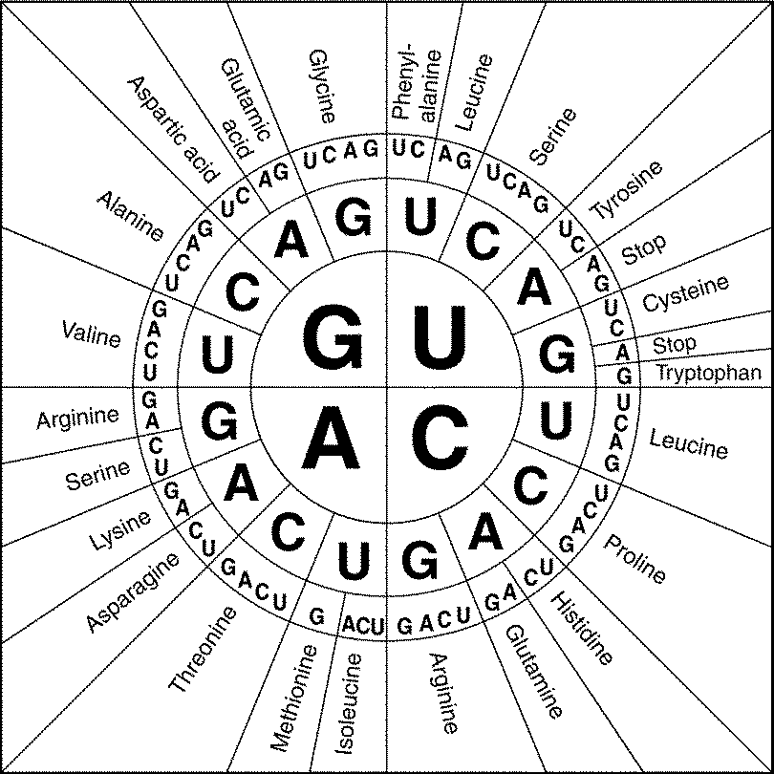

Figure 12-2

15.What does Figure 12-2 show?
16.How many codons are needed to specify three amino acids?
17.What happens during the process of translation?
18.During translation, the type of amino acid that is added to the growing polypeptide depends on what? (2 things)
19.Genes contain instructions for assembling what?
20.Which type of RNA functions as a blueprint of the genetic code?
21.What type of mutation involves a single nucleotide?
22.Which types of mutations can result in a frameshift mutation? Which type can’t?
23.What is a promoter?
24.If a specific kind of protein is not continually used by a cell, is the gene for that protein expressed continually, not at all or turned on and off at certain times?
25.Why do specialized cells regulate the expression of genes? What are the sites in the DNA called that regulate DNA expression?
26.What do Hox genes determine? Are they similar or different between different species?
27.How many directions does DNA replication occur in?
28. Which of the following is NOT generally part of a eukaryotic gene?operon, TATA box, promoter, enhancer
Chapter 14
- How many chromosomes are shown in a normal human karyotype?
- In humans, a male has how many X and how many Y chromosomes?
- Human females produce egg cells that have how many X and how many Y chromosomes?
- Name 2 diseases caused by a dominant allele and 2 caused by a recessive allele.
- Name a 2 traits determined by multiple alleles.
7..Compared with normal hemoglobin, how is the hemoglobin of a person with sickle cell disease different?
8.Many sex-linked genes are located on what chromosomes?
9.Colorblindness is more common in males than in females. Why?
10.What is a Barr Body? What causes it? What is the result?
11.The failure of chromosomes to separate during meiosis is called what?
12.Which of the following combinations of sex chromosomes represents a female: XY, XXY, XXXY, XX
13.The process of DNA fingerprinting is based on what fact?
14.What is the purpose of the Human Genome Project?
15.What is the purpose of gene therapy?

