California Water

In your seats, use the maps and the Water Fact Sheet to answer the questions. Answer the questions on your own paper, using complete sentences.

Average Annual Precipitation Map:
Review the map legend.
1. Describe patterns you notice in precipitation.
2. Describe any anomalies you notice.

CA Rivers Map:
3. Describe patterns you notice about the location of rivers in California.
4. Describe any pattern you notice between this map and the previous Precipitation Map.

CA Population Map:
5. Describe the patterns you notice about population in California.

Read the Water Fact Sheet
6. Explain in several sentences why water is important to our society. Use your own words.

California Water Conclusions

Instructions:
In your lab groups, discuss the answers to the following questions. Write your answers on your poster paper. Be prepared to present your answers to the class.

Conclusion Questions:

- Where does California’s water come from?

- Which parts of CA receive the most water (precipitation)?

- Which parts of CA need the most water, based on population?

- Explain problems which could arise from your answers, and suggest possible solutions to the problems.
Water Fact Sheet

1. Q: What is most of the freshwater in the U.S. used for?
A: In 2000, about 346,000 million gallons per day of fresh water was withdrawn from our surface- and ground-water sources, such as rivers, lakes, reservoirs, and wells. Would you think that two uses of water, irrigation and thermoelectric-power production, would account for about 79 percent of water used in 2000? Here's the breakdown by water-use category:
Irrigation: 40 percent
Thermoelectric power: 39 percent
Public Supply: 13 percent
Industry: 5 percent
Livestock, aquaculture: less than 1 percent
Domestic (self-supplied): 1 percent
Mining: 1 percent
In a way, the large amount of water used for power production (electricity) is deceiving. It is mostly used to just cool the heated power-production equipment. The vast majority of the water used by power plants is returned to the environment, and thus is available for other uses.

2. Which states use the most water?
A: In 2000, California alone accounted for almost 11 percent of all freshwater used in the United States. After California was Texas, Idaho, and Illinois, which together accounted for 28 percent of all fresh water used in the U.S. Most of the water used in California was for crop irrigation. In fact, 22 percent of all the Nation's irrigation water used was in California, which indicates how important agriculture is there. Florida also is a large food producer but because it gets a lot more summer rainfall than the Central Valley of California, there is less need to apply irrigation water.
The three most populated states, California, Texas, and New York accounted for 30 percent of all water withdrawn for public-supply uses (for example, a city/county withdrawing water and delivering it to our homes and businesses). Texas, Wyoming, and Oklahoma used the most water for mining purposes, and California, Michigan, and Florida used the most water for household (domestic) purposes.

3. Q: Which states used the most water for irrigation?
A: Agriculture is a big business in the United States, and a lot of water is used to produce our food. In 2000, farmers used water to irrigate about 61,900,000 acres of land. That is about 96,700 square miles, which you can think of as a big, square plot of land about 311 miles on a side. And that is only the land that was irrigated; other land produced crops without the use of irrigation.
As expected, California led the Nation in acres irrigated, about 10,100,000, which was over 16 percent of the national total. Nebraska was next, irrigating about 7,420,000 acres, followed by Texas at about 6,490,000 acres. Agricultural irrigation is much more prevalent in the arid Western United States than in the East. The Western U.S. accounts for the majority of irrigation water use.

4. Q: How much water do Americans use each day?
A: Per capita fresh water use in the United States is now over 1,900 gallons per day. This is found by dividing the total water used for ALL purposes listed above by the population.
If all other water uses are excluded, the average person uses 20 to 80 gallons of water each day in the home (washing dishes - 10 gallons; flushing a toilet - 3 gallons; a shower or bath - 20 to 30 gallons; a washing machine load - 20 to 30 gallons).

From http://ga.water.usgs.gov/edu/qausage.html#HDR1 and http://www.cvwater.org/facts.htm

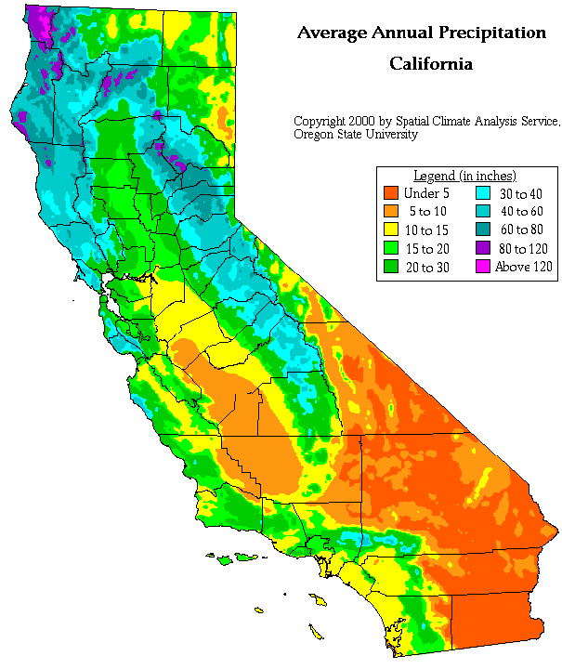
California Rivers Map
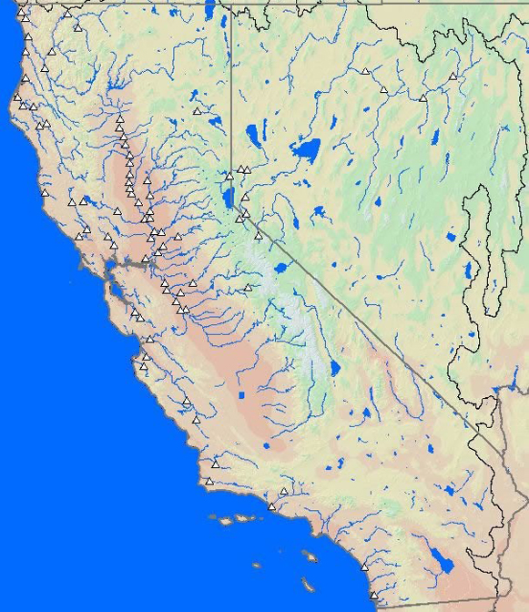
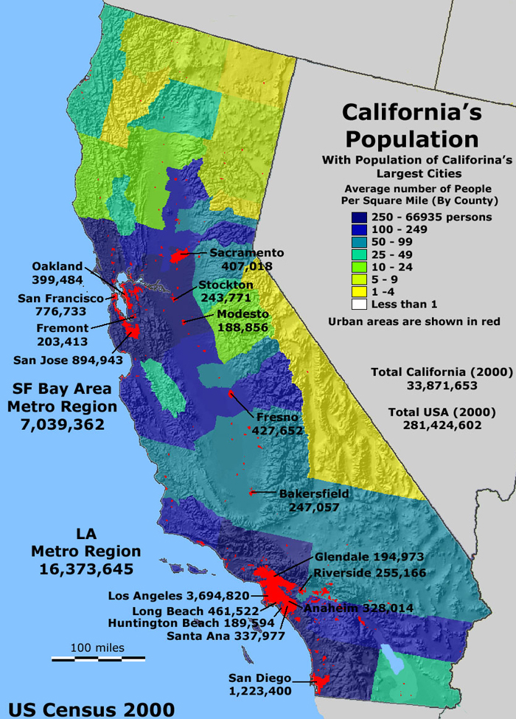
California’s Water Aqueduct System


